Lab 6.5 Liveness & Readiness Probes

- Create a Dry run yaml using this command:
kubectl create deploy livenessprobe --image busybox -o yaml --dry-run > livenessprobe.yml

- Update the YAML file to be as shown:
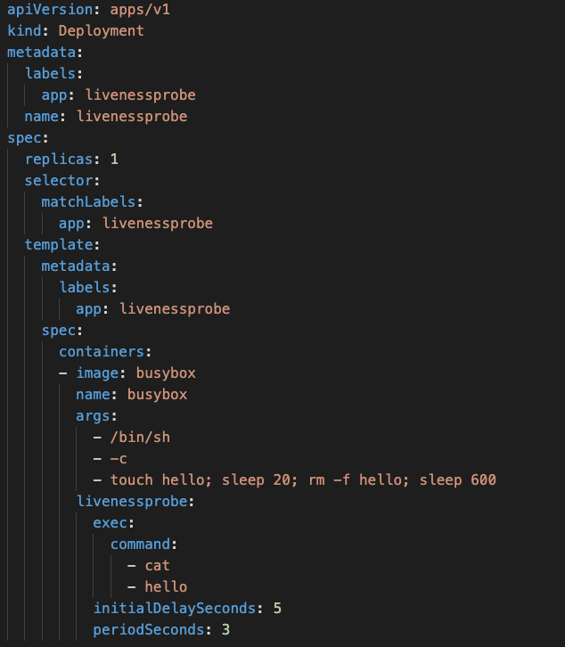

- Create the Pod
kubectl create -f livenessprobe.yml

- Validate if everything is working well.
kubectl get all

- Check the Events and notice the Unhealthy message
Kubectl get events

- Check the number of restarts
kubectl get pods

- Create a readinessProbe.yml
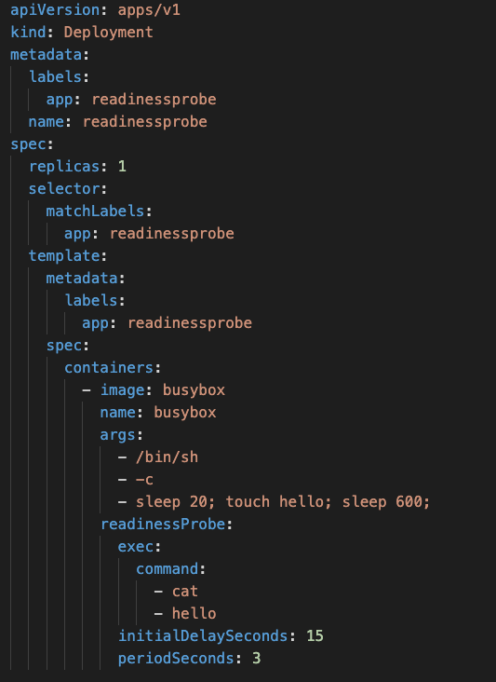

- Create the Pod
kubectl create -f readiness-probe.yml

- Check the Ready state of the Pod. It would not be ready for up to 15s
kubectl get all

- Delete both the Pods

